Buena Vista High School


2024-2025
Staff Handbook

  - .

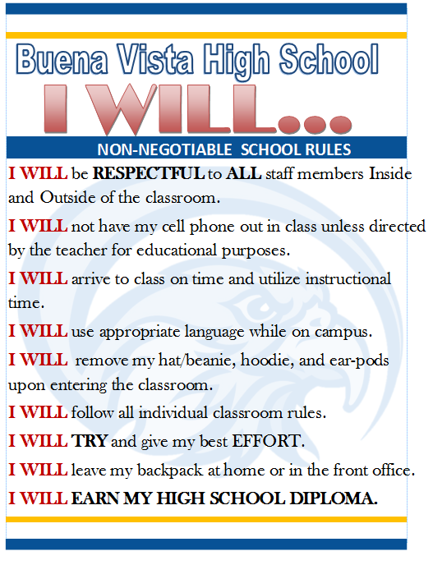
Bell Schedule

Regular Day
Period 1 | 8:30-9:15
Period 2 | 9:18-10:03
Nutrition | 10:03-10:13
Period 3 | 10:16-11:01
Period 4 | 11:04-11:54
Lunch | 11:54-12:24
Period 5 | 12:27-1:12
Period 6 | 1:15-2:00
Meetings  (CSS, IEP, 504, Staff, WASC, Professional Staff Development, etc.) | 2:15-2:55

Minimum Day
Period 1 | 8:30-9:05
Period 2 | 9:08-9:43
Breakfast | 9:43-9:53
Period 3 | 9:56-10:31
Period 4 | 10:34-11:09
Nutrition | 11:09-11:19
Period 5 | 11:22-11:57
Period 6 | 12:00-12:35

Year Long Calendar
2024– 2025

- July 30, 2024 New Student Orientation @10:00am & 2:00pm
- August 2, 2024 Teacher Work Day; Staff Development Meeting
- August 5, 2024 First Day of School
- August 20, 2024 New Student Orientation @3:00pm
- August 27, 2024 PLC @2:15pm
- September 2, 2024 Labor Day Observed – No School
- September 4, 2024 Back to School Night – 6:00 to 7:30pm
- September 12, 2024 Staff Meeting @2:15pm
- September 24, 2024 PLC @2:15pm
- October 1, 2024 New Student Orientation @3:00pm
- October 4, 2024 End of Qtr 1; Minimum Day- Dismissal @12:35
- October 07, 2024 1st Day of Quarter 2
- October 10, 2024 Staff Meeting @2:15pm
- October 29, 2024 PLC @2:15pm
- November 01, 2024 School Closed
- November 11, 2024 Veterans Day Observed – No School
- November 14, 2024 Staff Meeting @2:15pm
- November 25-29, 2024 Thanksgiving Break – No School
- December 10, 2024 New Student Orientation @3:00pm
- December 18, 2024 End of Qtr 2; Minimum Day- Dismissal @12:35
- December 19, 2024 Student Free Work Day
- Dec. 19 to Jan. 3, 2025 Winter Break – No School
- January 6, 2025 1st Day of Quarter 3
- January 09, 2025 Staff Meeting @2:15pm
- January 20, 2025 Martin Luther King, Jr. Day – No School
- January 28, 2025 PLC @2:15pm
- February 10, 2025 Lincoln’s Birthday – No School
- February 13, 2025 Staff Meeting @2:15pm
- February 17, 2025 Washington’s Birthday – No School
- February 25, 2025 PLC @2:15pm
- March 4, 2025 New Student Orientation@3:00pm
- March 7, 2025 End of Qtr 3; Minimum Day- Dismissal @12:35
- March 10, 2024 1st Day of Quarter 4
- March 13, 2025 Staff Meeting @2:15pm
- March 24-28, 2025 Spring Break- No School
- April 2, 2025 Open House Night – 6:00 to 7:30pm/ Cap & Gown
- April 10, 2025 Staff Meeting @2:15pm
- April 18, 2025 School Closed
- April 29, 2025 PLC @2:15pm
- May 8, 2025 Staff Meeting @2:15pm
- May 19 – 22, 2025 Minimum Day – Dismissal @12:35
- May 21, 2025 Graduation 6pm
- May 22, 2025 Last Day of School
- May 23, 2025 Teacher Work Day



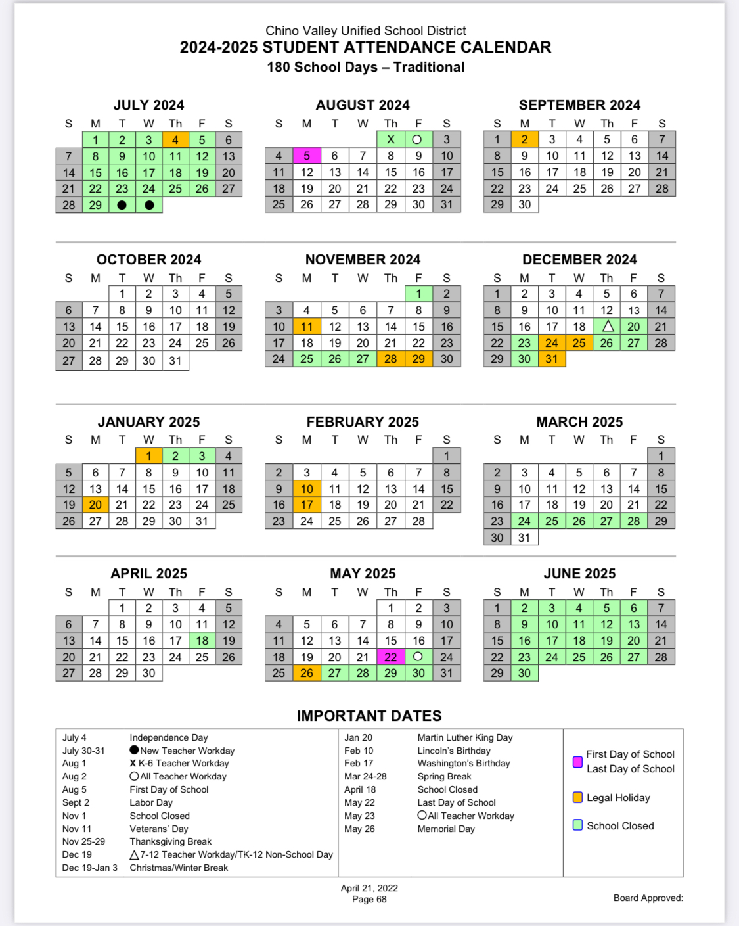

STAFF CONTACT LIST
 | Location | Extension
Kyle Shuler | Principal | 7970
Teresa Marquez | Office | 7951
Holly Tucker | Office | 7952
Sherry Ma | Nurse | 7953
Erica Ramos | Office | 7954
TBD | SRO | 7980
Infant Toddler Center | 15, 16, 17 | 7917
Tisha Clay | Counseling | 7944
Veronica Garcia | Int. Counseling | 7943
Modell McEntire | Psychologist | 7942
Gina Huerta | Library | 7940
Don Schenkel | Security | 7945
Zen Den | Lab | 7946
Carrie Ermer | Kitchen | 7986
Teachers
Arroyo, Rosalia | 35 | 7935
Beard, Daura | Portable 1 | 7923
Brown, Melissa | 31 | 7931
Gamboa, Myra | 22 | 7922
Jachmann, Alison | 34 | 7934
Kelly, Erica | 11 | 7911
Killinger, Greg | Portable 2 | 7924
Laird, Shae | 41 | 7941
Larson, Thomas | Portable 3 | 7925
Lipsey, Janice | 21 | 7921
Mariott, David | 10 | 7910
Prieto, Stacy | 32 | 7932
Sander, Rick | Portable 4 | 7926
Poland, Michael | 30 | 7930
Vergara, Sandra | 33 | 7933

GRADUATION REQUIREMENTS

Each student graduating from Buena Vista High School (or from any high school in the C.V.U.S.D.) must earn 225 units of credit in the following areas and have at least a 2.0 Grade Point Average.
The following criteria must be met to gain credits:
- Student must meet all course standards and satisfactorily complete all assignments.
- Receive 70% scores on assigned course work, including tests and quizzes.
- Complete course work within a quarter. One quarter is equivalent to a semester.

Minimum High School Graduation Requirements

CLASSES UNITS NEEDED
English 40

Social Science 30
World Civilizations 10
U.S. History 10
Economics 05
U.S. Government 05

Science 20
Life Science (Biology) 10
Chemistry 10

Mathematics 30

Visual/Performing Arts/Foreign Language/CTE* 20

Physical Education 20

Health Science 5

General Electives 60
___________
TOTAL 225

*An approved Career Technical Education Course (CTE) may replace 10 credits of Visual/Performing Arts.

EMERGENCY PROCEDURES
Evacuation
In case of an emergency and if necessary, to protect employees and students the building may have to be evacuated. This is a decision that will be made by the principal, utilizing all available information. However, there may be instances when local fire, disaster or police personnel may order evacuations. Evacuations will be orderly and practiced throughout the year.
Teachers shall take laptop/attendance rooster and shall call roll after evacuation and report missing students to the principal. Teachers shall also lock all doors and bring their first aid kit with them to the Assembly Area.
Office staff shall take laptop and sign out sheets for offsite student release if required.
The custodian shall be responsible for shut-off valves for gas, water and electricity and shall ensure that no hazards result from broken or downed power.
An outdoor assembly has been designated for evacuations. In the event of an actual disaster, all students and employees shall go to the blacktop area. The classes will be placed in the blacktop area in such a way that dismissal of students and staff will be orderly and efficient.
Within close proximity of the blacktop area, a student release station, first aid station, and command communication station will be set up.
No student shall be dismissed until appropriate procedures are followed.

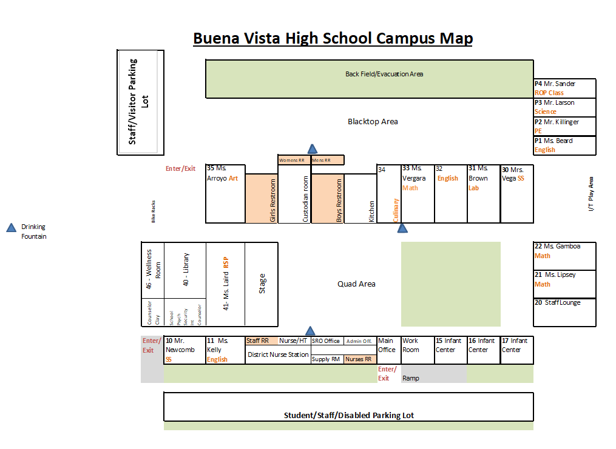

DISCIPLINE

Administrative Regulation (AR 5144 (a))
Since the major function of the public school is the preparation of youth for citizenship in a democracy, it is essential that respect for law and order shall be instilled in the minds of every student. In any society, the majority follows their inclinations to be good citizens without compulsion, but there are a few who obey only when it pleases them or when the certainty of punishment acts as a deterrent.
Discipline is based on reformative or preventive procedures instead of punitive. It shall be the policy of the school to carry on with the least number of rules necessary for a good educational program in a friendly atmosphere that is conducive to good study habits and to insist that the rules be obeyed.
Our first responsibility shall be to train our students in good study habits and attitudes of good citizenship that will cause them to be considerate of the welfare of their fellow students and be law abiding with respect to the rules and regulations of the school and the state.
It shall be the responsibility of the teachers and administration to see that the rules are fair and reasonable and necessary for the successful operation of our school. Every teacher and administrator shall assume responsibility for enforcement of the rules in the classroom and elsewhere on the campus.
The teacher should do everything in his power to solve the problem. This should include communication with the student and sometimes with the student’s parents/guardians. If the teacher is unable to work out the problem, it should be referred to the counselor for help. Expectations and teacher consequences are best specified in the classroom Discipline Plan.

CLASSROOM DISCIPLINE
Public schools have an obligation to maintain a safe and orderly environment for learning for all individuals. Any behavior that interferes with another student’s right to learn is unacceptable. Any behavior on the part of a student that tends to undermine the authority of the teacher on campus or in the classroom and/or any other staff member will not be tolerated. Counseling is an integral part of the CVUSD’s discipline program. The counselor will aid the teacher in a preventative approach to discipline through student counseling, and parent/teacher conferences. A teacher may suspend a student from his/her classroom for up to two days for disciplinary reasons (the day of the transgression and the following day) per Education Code 48910.

DISCIPLINE REFERRAL PROCEDURE

Teachers:
It is the classroom teacher’s responsibility to demand proper behavior from students. Classroom rules/Expectations with consequences should be reviewed by the teacher and a copy of them posted in the classroom. A copy of your Classroom Rules/Expectations with Consequences should be sent home for parents/guardians at the beginning of the school year. Teachers have the responsibility to impose controls and penalties upon students whose behavior distracts from a healthy learning situation or who are in violation of classroom rules/expectations. The controls and/or penalties that are appropriate are listed below:
- Denying certain privileges granted to the student, i.e. denial of extra credit work, loss of free study time, loss of any bonus points, etc.
- Contact/Conference with parents ASAP by text, phone or email to secure their assistance by phone or in person in order to improve the quality of performance and/or behavior of their student.
- Referring the student who commits repeated offenses to the counselor. Some record should be kept of these responses (back-up sheet).
SAMPLES OF INFRACTIONS TO BE HANDLED BY THE TEACHER:
* Disruptive talking * Not participating * No notebook and/or pencil/pen
* Eating/drinking in class * Not paying attention * Chewing gum
* Use of Electronics * No materials * Horse playing
* Use of profanity * Sleeping in class * Cheating
* Not following directions * Homework not turned in * Disobeying teacher
* Applying Make-up * Leaving seat/class without permission

Education Code 48910-Suspension by a Teacher
A teacher may suspend a pupil from the teacher’s class, for any of the acts enumerated in Section 48900, for the day of suspension and the day following. The teacher shall immediately report the suspension to the principal (or designee) of the school and send the pupil to the principal or principal’s designee for appropriate action. In addition, the teacher will contact the parent as soon as possible to apprise the parent of the student’s misbehavior in class and to set up a teacher-parent conference ASAP.

STUDENT DRESS CODE
It is the intent of the Board of Education that students be dressed and groomed in a manner which will not interfere with or detract from a school environment conductive to academic learning or study.

- Students may be sent home to change for wearing any article of clothing that is deemed by staff/administration to be offensive/inappropriate for school even if it is not specified below.
- Shoes must always be worn. The absences of shoes will only be allowed upon proof of medical necessity. (Slippers & Backless/strapless are not permitted).
- The lack of undergarments is not permitted. Clothing which allows undergarments to be visible is not permitted.
- The absence of a shirt or other clothing that covers the upper torso is not permitted.
- Bare midriffs are not permitted.
- Tube/strapless, halter, spaghetti strap tops without a covering blouse or jacket are not permitted. Spaghetti straps are less than 1 inch in width.
- Bathing suits are not permitted.
- Short shorts, which allow undergarments to be visible, or the upper thigh/buttocks to be visible are not permitted.
- Dresses, skirts, or shorts that are shorter than six inches above the knee are not permitted.
- Tattered clothing is not permitted; this includes torn jeans or jeans with holes.
- Clothing containing emblems, printing, lettering, or pictures pertaining to drugs, alcohol, profanity, or sexual in nature (including bikini-clad women) are not permitted.
- Sunglasses are not permitted unless they are medically prescribed by a doctor.
- Any gang-related attire, which includes, but is not limited to, oversized pants, oversized shorts with long white socks, or oversized overalls are not permitted. Pants must fit at the waist without requiring alteration. Military-style clothing and trench coats could also be excluded.
- Shoestrings, twine, oversized, or hanging belts are not permitted.
- Obscene, profane or vulgar tattoos must be covered at all times. Body markings are not permitted.
- Accessories such as, but not limited to, hairnets, shoestrings, wristbands, belts, belt buckles, chains, beanies, bandanas, which advocate and/or cause disruption on campus and/or other acts of violence or may be used as weapons are not permitted.
- Only unaltered medically or religiously required hats or head coverings or unaltered school hats, as approved by the school principal are allowed (at principal’s discretion). This includes sweatshirt hoods, beanies, sock hats, or any other type of head covering.
- Pajamas or pajama-type attire is not acceptable or appropriate for school.

District Dress Standards Apply and Are as Follows:
It is the intent of the Board of Education that students be dressed and groomed in a manner which will not interfere with or detract from a school environment conducive to academic learning or study, disrupt or threaten to disrupt the educational or instructional process or create or present an unnecessary or unreasonable risk of injury or harm to any student.
It shall be the policy of the Chino Valley Unified School District to enforce the requirements of Title 5 Section 302, of the California Administrative Code, which provides:
“A student who goes to school without proper attention having been given to personal cleanliness or neatness of dress, may be sent home to be properly prepared for school, or shall be required to prepare himself/herself for the school room before entering.”

Guidelines for Student Dress
- Student dress, which disrupts or threatens to disrupt the instructional process, or which creates an unnecessary or unreasonable risk of injury or harm to any student is prohibited.
- Student grooming which disrupts or threatens to disrupt the instructional process, or which creates an unnecessary or unreasonable risk of injury or harm to any student is prohibited.

Determination of Violation
- Dress or grooming by a student, who violates the district guidelines but is not expressly, delineated within District or school site regulations shall be considered and reviewed by the site administrator in charge. The site administrator shall make a determination of whether the dress or grooming matter at issue violates District policy and, if so, shall undertake appropriate action to immediately bring about the student’s compliance with the district guidelines including, but not limited to contacting the student’s parents/guardians and seeking the cooperation and assistance of the parents/guardians.
- Any student who violates any District or school site dress or grooming regulation may be required to prepare him/herself in accordance with the dress and grooming regulations before entering the school. After communications with the student’s parents/guardians, the student may be sent home to comply with the dress and grooming regulations. Said actions shall be considered disciplinary actions and shall be listed in the disciplinary record of the student. However, repeated failure to comply may result in disciplinary action.

EXPECTATIONS FOR STAFF

Professional Workday
CVUSD/ACT/CTA/NEA Contract Article 14.1 & 14.2 states that a teacher’s workday shall consist of 7 hours a day. While a teacher’s workday usually exceeds the time provided by contract, he/she is to be on campus from 8:15 a.m. to 3:15 p.m.
It is helpful to have your room open as far in advance of the first bell as possible. This courtesy is especially important during rainy weather.
Evaluation
It is the district’s policy to evaluate all staff members. According to Article 8 of the ACT Contract, there will be a new evaluation process in which evaluators will use the new forms set forth by the District and ACT. Further information will be given to teachers as it becomes available on the new evaluation process.
Absences
The Aesop service will be available to you 24 hours a day, 7 days a week and can be accessed via the internet, please use Aesop to report your absence.
*All sub requests should be submitted as early as possible.
*All requests must go through the Aesop service. The district office will automatically drop any substitute who accepts a new assignment directly from either a teacher or school secretary.
*A half-day sub is either three periods or three hours, whichever is appropriate (lunch or prep periods count as a period).
*Teachers wishing to leave early for any reason (single or multiple period absences), must contact the principal for approval and assignment of class coverage. Teachers may not contact other teachers to cover a period absence without prior approval from the principal.
Plan your class well enough to allow your substitute to enjoy teaching your students!
Lay a thorough groundwork of high standards of citizenship in all classes.
- Emphasize student responsibility in carrying out the work scheduled for the substitutes.
- Outline clearly the attitudes and courtesy expected. In addition to the above pre-planning, the following preparation is necessary and expected:
  - Furnish a written plan that you wish to have followed
  - Name the textbook in use, giving the author’s name
  - Be sure to leave current seating charts readily available.
  - Have a class roster readily available. On this roster indicate at least two students who will be helpful with class details.
  - A previous arrangement with your neighboring teacher to show the substitutes “the ropes” would be a helpful, reciprocal plan.
  - If you know of any of your classes that might present a special problem, please feel free to state this fact.
  - If you are going to be absent for an extended period of time, please get in touch with your substitute by letter or phone.
Substitute Teacher Packets/Lesson Plans
Positive classroom teaching and management is enhanced if students have a clear sense of the goals of the course, as well as the day. Clearly communicated objectives help students recognize their responsibilities and the scope of the lesson.
Please complete a folder or box of emergency lesson plans (class sets photocopied with instructions). These will be used in the event of an unplanned absence. Emergency Lesson Plans need to be provided to the office for storage no later than Friday, August 26, 2022.

Professional Courtesy
Often a substitute teacher cannot be secured, and you may be asked to help out by covering a class during your prep period. It is much appreciated when you help your colleagues by taking the assignment.

Teacher Injury
If you are injured while on duty, it is your responsibility to contact the principal or designee immediately and fill out the appropriate forms available from the School Secretary within 24 hours of the injury. You will be directed to first call the “on-call Nurse” at 877-854-6877.

Student Injury Reporting
You are legally responsible for the safety of the students assigned to you each period.
If you leave, your absence might be considered as negligence on your part; should you be away from your classroom when a student is injured, the chances of you proving that a condition of negligence did not exist might be difficult. Do not leave your classroom unattended. If you need to leave your classroom, please contact the office. Arrangements will be made for you. If you have a student that is injured or in need of medical assistance, please contact the office.

Class Dismissal
Students are to remain in class until the bell rings. Remember that YOU dismiss students and not the bell. Do Not release students before the bell rings!
Staff Telephone Calls
Staff members should not make or receive personal phone calls (including calls on a cellular phone) during classroom hours. Teachers, especially, may not leave a classroom unattended to make or take calls on his/her cellular phone.
Personal Long Distance Phone Calls
We have been directed by the district office that NO PERSONAL LONG-DISTANCE calls be made on the school telephones. Under no circumstance should you allow a student to use your classroom telephone. This includes allowing a student to make ‘internal’ calls to the office or other classrooms.
Classroom Coverage
Teachers needing to leave early for any reason (single or multiple period absences), must contact the principal for approval and assignment of class coverage. Teachers may not contact other teachers to cover a period absence without prior approval from administration. A teacher who leaves early will be marked down as a “Personal Necessity” for the length of the absence on the Absence Report.

Staff Communication
Regular faculty meetings are held as needed and will take place during Collaboration Time. In between meetings, communications via e-mail or memorandum will be forthcoming.

School Keys/Badge
DO NOT ISSUE SCHOOL KEYS OR BADGE TO ANY STUDENT UNDER ANY CIRCUMSTANCE. Report any lost keys immediately to Maite Maisterrena, school secretary.

Staff Work Room
The staff workroom belongs to the staff. The staff workroom is located in the front office. This is the location of staff mailboxes and Canon machine. Each person who uses this room must take responsibility for its upkeep. Students are not allowed in the staff workroom.

Mail
It is the teacher’s responsibility to pick up their own mail. Students will not be allowed to have access to mailboxes or staff mail. (ACT Article 12.13)

Room Maintenance/Environment
It is the responsibility of each teacher to maintain an environment that is conducive to learning. Included in this environment should be:
- No trash on the floor
- No writing on the desks or tables (watch out for graffiti, report graffiti to campus security and/or administration)
- Maintain current and attractive bulletin boards pertaining to subject matter
- If there is a maintenance problem, please contact the principal
- Do not allow students to sit or stand on top of the desks
- Teachers are responsible for seeing that students do not eat/drink in the classroom.
- The custodial staff is here to assist you
- Please do not leave books, calculators, notebooks, etc. on floor at the end of the day.
- Please do not allow gum chewing in your classroom.
- After the end of every period, stack the books up in a convenient location in classroom. Do not leave books on the floor.

Student Passes
When releasing students during class time, be sure they have an official school (pink) pass. Any students found without appropriate passes will be returned to the teacher’s classroom. Student passes need to be completely filled out by the teacher with the student name, time out of class and destination (laminated passes, hand stamps, etc are not acceptable forms of passes). If you run out of passes, please contact the office and they will either be delivered to you or placed in your mailbox. Please refrain from issuing restroom passes the first & last 15 minutes of class.

Use of Videos/DVD’s
The Board of Education has stated that the use of videos and DVD’s have value as a supplement to the State Approved Curriculum. Any film, video or DVD that is checked out of the media center does not need special parent permission to show to students during class time. However, any other film, video or DVD that is to be shown in class, must have specific parent permission to be shown in class. (Board Policy 6162.7) Use of Videos/DVD’s are to be used to support a lesson or a standard in the subject area. Videos/DVD’s used for recreation and/or entertainment purposes are not appropriate.
Staff Dress
Teachers and staff members at Buena Vista High School are to maintain a professional appearance during their working hours. These standards may be different from areas of school operations (i.e. physical education or vocational classes) but should represent a model for students in their physical appearance and attitude. Your effort, as a staff, to dress accordingly is appreciated.
Collaboration for Student Success (CSS)
CSS’s will be scheduled throughout the school year. Starting times for CSS’s will be at 2:10 p.m., contingent on all parties being present and available on campus (parent/guardian, student, teachers, counselor and administration). If you are absent from school on the day of a CSS involving your student, please send a written report to Ms. Clay, the counselor, prior to 1:20pm. CSS’s are designed to chart a course toward graduation for a student who has been targeted for assistance. Notes will be taken and all parties will be involved in formulating a course of action for that student. If you wish to recommend a student for a CSS, please contact the principal.
504/IEP Meetings
Starting time, like CSS, will be at 2:10p.m., contingent on all parties being present and available on campus (parent/guardian, student, teachers, counselor and administration). If you are absent from school on the day of a meeting involving your student, please send a written report to Ms. Clay, the counselor, prior to 1:20pm.

Work Orders
Contact Teresa Marquez, School Secretary at ext. 7951 to report a needed repair. Please be specific as to what is needed, i.e., room number and location within the room.

Detection Canines
CVUSD is collaborating with the Chino Police Department to have random, unannounced K-9 searches conducted on campus, throughout the year. These dogs are searching for any illegal/unsafe contraband that students may bring on campus. Dogs may be asked to search student vehicles parked on campus.

NOTICE OF DUTY TO REPORT CHILD ABUSE

As the holder of a credential, certificate or permit which authorizes you to work with, observe, or have knowledge of children as part of your official duties, you are required by law to report every instance of child abuse which becomes known to you or which you reasonably suspect to have occurred to a child with whom you have professional contact.
You must report your observations to the Child Protective Services Agency immediately, or as soon as practicably possible by telephone and send a written report to the Child Protective Agency within 36 hours of you becoming aware of the abuse of the child.
Your duty to report is individual, and no supervisor or administrator may impede or inhibit your duty to report, although you may also report to your supervisor or administrator.
Your failure to report instances of child abuse known or reasonably suspected by you is a misdemeanor punishable by up to six months in jail or by fine of one thousand dollars ($1,000.00) or both.
Child Abuse Reporting Procedure
If you suspect child abuse/sexual assault, you must:
- Call Child Protective Services (CPS) at 1-800-827-8724.
- File a written report (11166P.C.) within 36 hours with Child Protective Services, P.O. Box 1088, Rancho Cucamonga, CA 91730. Secure the report form at: http://ag.ca.gov/childabuse/pdf/ss_8572.pdf

Search and Seizure
To protect the health, safety and welfare of students and staff, school officials may search students, their property and seize illegal, unsafe and prohibited items. (BP 5145.12 ca)
If you suspect a student is under the influence, please email Mr. Shuler, Maite, Holly, SRO Troncoso, Sherry Ma and Ms. Clay. We will come to pick up the student. This also applies if you suspect a possible drug transaction is taking place.

SEXUAL HARASSMENT

Once an employee or supervisor has knowledge that a discriminatory situation is occurring or has occurred, the supervisor has a responsibility to take immediate and corrective action even if a complainant asks that nothing be done! Silence and/or non-reaction can appear to make the employee a party to the discrimination.
Board Policy states: Sexual harassment of or by any employee and/or student shall not be tolerated. The Board considers sexual harassment to be a major offense, which may result in disciplinary action or dismissal of the offending employee.
Pursuant to Education Code 212.5, unwelcome sexual advances, requests for sexual favors, and other verbal or physical conduct of a sexual nature constitutes sexual harassment when:
- Submission to the conduct is made either an explicit or implicit condition of employment, status or promotion.
- Submission to or rejection of the conduct is used as the basis for an employment decision affecting the harassed employee.
- The harassment substantially interferes with an employee’s work performance or creates an intimidating, hostile, or offensive work environment.
- Submission to, or rejection of, the conduct is the basis for any decision affecting benefits, services, honors, programs or other available activities.
Employees
Any employee who believes he or she has been harassed by a co-worker, supervisor, or agent of the district should promptly report the allegations of the incident or incidents and the names of the individuals involved to his or her supervisor or to the Assistant Superintendent, Human Resources. Supervisors shall advise the employee of the right to make a report of alleged harassment to the Human Resources Department.

Students
Sexual harassment of the student by another student shall be reported to the site principal or designee who will take appropriate action in accordance with:
CVUSD File: 1003.0401 – R-Behavior Code
CVUSD File: 1004.05 – Expulsion
CVUSD File: 1004.0501 – R-School Site Responsibilities (Expulsion Code)

STUDENT SERVICES

Counselors
The roles of our Counselors are to advocate for safe supportive school environments where students can thrive socially, emotionally, and academically. If students have questions on academics, college, and career preparation, or if students are experiencing urgent personal issues* we ask you to send the student to Mrs. Huerta in the library, at ext 7940, she can help put student in contact with the appropriate counselor, or staff member.

- Tisha Clay, Academic Counselor: tisha_clay@chino.k12.ca.us
  - For academic support and college & career guidance
- Carlos Robles, Intervention Counselor: carlos_robles@chino.k12.ca.us
  - The Intervention Counselor is available to students, parents, and teachers by using the Request for Assistance form that is located through Buena Vista’s website under the Academic > Counseling > Intervention tab
- Tasha Rideout, School Psychologist: tasha_rideout@chino.k12.ca.us
  - A school psychologist is available to assist the staff with student referrals for testing and special programs
.
Crisis Intervention Team
A crisis intervention team staffed with school and district personnel is available for emergency services to students and staff. In addition, the County of San Bernardino Children’s Crisis Response Team is available for student intervention. Contact administration if you have a student in need of these services.
Chino Community Services
Chino Community Services provides an excellent support service for the student needing counseling and/or social services. Please discuss any student you may be concerned about with an administrator who will make the appropriate referrals. Substance abuse counseling is available and is recommended for every student involved in substance abuse on our campus. In-services for staff and classroom programs are available.
Baldy View Regional Occupation Program (ROP)
The regional occupational program is an excellent way for Buena Vista students to earn elective credits, explore career choices, and learn skills for employment. ROP classes utilize a hands-on approach to learning skills in the work world. The Buena Vista ROP Career Guidance Specialist is Gina Huerta at ext. 7940, she is available in the library to assist all students in selecting appropriate classes. The credits earned count toward graduation at any school in Chino Valley Unified School District.
Student Work Permits
The Education Code and California child labor laws state that no minor under eighteen years of age may be permitted to work at anytime without first securing a “Permit to Work” from the school. At Buena Vista High School, work permits may be obtained from Mr. Shuler in the front office.
Quarter Grading System
In 2016, BVHS went to a quarter system format for students to recover credits. The quarter
system is designed for students to recover credits at a rapid rate. It is critical to keep students and their parents/guardians informed as to their progress (or lack of) within a quarter.
School Resource Officer (SRO)- Jessica Asbee is a sworn Chino Police Department officer
who is on campus four days per week to meet with students and investigate incidents that may lead to a notice to appear in court or issuance of a ticket, etc. Her extension is 7980
Campus Security-One campus security officer, Don Schenkel, has been assigned to BVHS.

TEACHER EVALUATION CRITERIA
Standard 1  Engaging & Supporting All Students in Learning | Exceeds Element Expectations | Meets Element Expectations | Meets Element Expectations with  Growth Recommended | Element Expectations  Not Met
Connecting students' prior knowledge, life experience, and interests with learning goals | The teacher facilitates as students connect and apply their prior knowledge, life experiences, and interests to new learning and the achievement of learning goals. The teacher builds on students' questions and comments during lessons to modify instruction. | The teacher makes substantial connections between the learning goals and the students' prior knowledge, life experiences, and interests. The teacher elicits and uses students' questions and comments during a lesson to extend their understanding. | The teacher makes some connections between the learning goals and the students' prior knowledge, life experiences, and interests. The teacher elicits some questions from students during a lesson to monitor their understanding. | The teacher makes no connection between the learning goals and the students' prior knowledge, life experiences, and interests. The teacher does not elicit student questions or comments during a lesson.
Using a variety of instructional strategies and resources to respond to students' diverse needs | The teacher makes skillful use of a wide repertoire of instructional strategies to engage all students in learning, and makes adjustments while teaching to respond to students' needs. | The teacher uses a variety of instructional strategies that are appropriate to the students and the instructional goals. The teacher carries these strategies out thoughtfully, and makes some adjustments to respond to students' needs. | The teacher uses a selection of instructional strategies that are largely appropriate to the students, and the instructional goal, but they may lack variety or may not be responsive to students' needs. | The teacher uses instructional strategies, but they lack variety, are poorly carried out, or are inappropriate to the students or to the instructional goals. No adjustments are made to respond to students' needs.
Facilitating learning experiences that promote autonomy, interaction, and choice | Learning experiences are facilitated by the teacher and students to promote and support a variety of constructive interactions, autonomy, and choice in the pursuit of significant learning. | Learning experiences are facilitated by the teacher to promote constructive interactions, autonomy, and choice, and to encourage and support student involvement in learning. | Learning experiences are directed by the teacher and allow limited student autonomy, interaction and choice. | Learning experiences are directed by the teacher, permitting no student autonomy, interaction, or choice.
Engaging students in problem solving, critical thinking, and other activities that make subject matter meaningful | Learning opportunities are provided that extend student thinking, and engage and support all students in problem posing, problem solving, inquiry, and analysis of subject matter concepts and questions within or across subject matter areas. | Learning opportunities and support are provided for students to engage in problem solving and in investigating and analyzing subject matter concepts and questions within subject matter areas. | Some learning opportunities are provided for students to engage in problem solving within subject matter areas, but little support is given to develop necessary skills. | No learning opportunities are provided for students to engage in problem solving, analysis, or inquiry within or across subject matter areas.
Promoting self-directed, reflective learning for all students | Students take initiative for their own learning, and reflect on, talk about, and evaluate their own work with peers. | Students are supported in developing the skills needed to monitor their own learning during activities. Students reflect on their own work.. | Students' learning is directed and monitored by the teacher, and some opportunities are provided for students to reflect on their work individually. | No opportunities are provided for students to initiate their own learning or to monitor their own work.

Standard 2  Creating & Maintaining Effective Environments for Student Learning | Exceeds Element Expectations | Meets Element Expectations | Meets Element Expectations with  Growth Recommended | Element Expectations  Not Met
Creating a physical environment that engages all students | The arrangement of the physical environment ensures accessibility and facilitates constructive interaction and purposeful engagement for all students in learning activities. | The arrangement of the physical environment ensures accessibility. Most students work well individually or together as they participate in learning activities. | The physical environment is arranged for accessibility, and it facilitates individual student engagement in learning. | The physical environment does not support student learning. Materials are difficult to access when needed.
Establishing a climate that promotes fairness and respect | Students ensure that a climate of equity, caring, and respect is maintained in the classroom. The pattern of teacher response to inappropriate behavior is fair and equitable. | A climate of fairness, caring, and respect is maintained by the teacher. The pattern of teacher response to inappropriate behavior is fair and equitable. | A climate of fairness, caring and respect is established by the teacher for most students, but the teacher does little to encourage them. For the most part, the pattern of teacher response to inappropriate behavior is fair and equitable. | The classroom climate is characterized by unfairness or disrespect, either between the teacher and students or among students. Teacher response to inappropriate behavior is unfair or inequitable.
Promoting social development and group responsibility | Students work independently and collaboratively and maintain a classroom community in which they respect each other’s differences, assume leadership, and are responsible for themselves and their peers. | Students respect each other's differences and work independently and collaboratively, taking responsibility for themselves and their peers. | Students respect each other’s differences most of the time and work together moderately well. The teacher provides limited opportunities for students to assume responsibility. | Students’ social development, self-esteem, and diversity are not supported, and students have no sense of responsibility for each other.
Establishing and maintaining standards for student behavior | Students and teacher develop standards for behavior together, and students are responsible for helping each other maintain standards. | Standards for behavior are established, are clear to all students, and are maintained by the teacher. The teacher's response to student behavior is appropriate. | Standards for behavior have been established by the teacher, and the teacher’s response to student behavior is generally appropriate. | No standards for behavior appear to have been established, or students are confused about what the standards are.
Planning and implementing classroom procedures and routines that support student learning | Students and teacher ensure that classroom procedures and routines operate seamlessly and efficiently. | Procedures and routines work smoothly, with no loss of instructional time. | Procedures and routines have been established and work moderately well with little loss of instructional time. | Classroom procedures and routines have not been established or are not being enforced.
Using instructional time effectively | Pacing of the lesson is adjusted as needed to ensure the engagement of all students in learning activities. Transitions are seamless. | Pacing of the lesson is appropriate to the activities and enables all students to engage successfully with the content. Transitions are smooth. | Instructional time is paced so that most students complete learning activities. Transitions used to move students into new activities are generally effective. | Learning activities are often rushed or too long, and transitions are rough or confusing, resulting in a loss of instructional time.

Standard 3  Understanding &Organizing Subject Matter | Exceeds Element Expectations | Meets Element Expectations | Meets Element Expectations with  Growth Recommended | Element Expectations  Not Met
Demonstrating knowledge of subject matter content and student development | The teacher’s working knowledge of subject matter and individual students’ development incorporates a broad range of perspectives, strongly supports all students’ learning, and is current. | The teachers’ working knowledge of subject matter and basic principles of student development incorporates different perspectives, supports all students’ learning, and is current. | The teacher’s working knowledge of subject matter and basic principles of student development reflects a single perspective, supports some student s’ learning, and is usually current. | The teacher’s working knowledge of subject matter and student development is inconsistently evident, does not adequately support students’ learning, or may not be current.
Organizing curriculum to support student understanding of subject matter | The curriculum is organized and sequenced and demonstrates concepts, themes, and skills, and the relationships between them. It reveals and values a broad range of perspectives, and is organized to ensure that all students develop a deep understanding of core concepts. | The curriculum is organized and sequenced;  demonstrates concepts, themes, and skills; reveals and values different perspectives; and supports an understanding of core concepts for all students. | The curriculum is loosely organized; inconsistently demonstrates concepts, themes, and skills without revealing or valuing different perspectives; and supports an understanding of core concepts for some students. | The curriculum is not organized and it rarely demonstrates concepts, themes, and skills; rarely values different perspectives; or rarely supports students’ understanding of core concepts.
Interrelating ideas and information within and across subject matter areas | The teacher facilitates students as they identify and integrate concepts and information within and across curriculum, relate content to their lives and previous learning, and use this to extend their understanding. | The teacher identifies and integrates key concepts and information within the curriculum, relates content to students’ lives, and uses previous learning to extend students’ understanding. | The teacher identifies some key concepts and information within the curriculum, and attempts to relate content to previous leaning without extending students’ understanding. | The teacher presents curriculum without identifying or integrating key concepts and information, or does not relate content to previous learning in order to support students’ understanding.
Developing student understanding through instructional strategies that are appropriate to the subject matter | A repertoire of instructional strategies is used to make content accessible to all students, to challenge them to think critically, and to deepen their knowledge of and enthusiasm for subject matter. | The teacher uses appropriate instructional strategies to make content accessible to students, to encourage them to think critically, and to extend their knowledge of subject matter. | The teacher may use a few instructional strategies to make the content accessible to students, and may encourage some students to think critically or to extend their knowledge of subject matter. | Instructional strategies are not appropriately matched to subject matter content or concepts, and do not encourage students to think critically or to extend their knowledge.
Using material, resources and technologies to make subject matter accessible to students | A range of instructional materials, resources, and technologies are integrated into the curriculum to extend students’ understanding of content and concepts. Materials reflect diverse perspectives. | Instructional materials, resources, and technologies support the curriculum and promote students’ understanding of content and concepts. Materials reflect diverse perspectives. | Instructional materials, resources, and technologies are used infrequently to convey key subject matter concepts. Materials may reflect diverse perspectives. | Instructional materials, resources, and technologies are either not used or used inappropriately. Materials do not accurately reflect diverse perspectives.

Standard 4  Planning Instruction & Designing Learning Experiences for All Students | Exceeds Element Expectations | Meets Element Expectations | Meets Element Expectations with  Growth Recommended | Element Expectations  Not Met
Drawing on and valuing students’ backgrounds, interests, and developmental learning needs | Instructional plans build on students’ backgrounds, experiences, interests, and developmental needs to support all students’ learning. | Instructional plans reflect students’ backgrounds, experiences, interests, and developmental needs to support students’ learning. | Instructional plans are partially drawn from information about students’ backgrounds, experiences, interests, and developmental needs to support students’ learning. | Instructional plans do not match or reflect students’ backgrounds, experiences, interests, and developmental needs, and do not support students’ learning.
Establishing and articulating  goals for student learning | Short-term and long-term instructional goals are set by teacher and students, and integrate students’ language, experience, and school expectations. Goals are appropriately challenging for all students and represent valuable learning. Expectations for students are consistently high. | Short-term and long-term instructional goals are based on students’ language, experience, or school expectations. Goals are appropriately challenging for most students and represent valuable learning. Expectations for students are generally high. | Some instructional goals address students’ language, experience, and/or school expectations. Expectations for students are inconsistent. | Instructional goals are not established or do not address students’ language, experience, or home and school expectations. Expectations for students are low.
Developing and sequencing instructional activities and materials for student learning | Instructional activities and materials are differentiated to reflect individual students’ interests and developmental needs, and engage all students in meaningful learning. Activities support the learning goals and are logically sequenced to clarify content and concepts. | Instructional activities and materials are appropriate to students and the learning goals, make content and concepts relevant, and engage most students in meaningful learning. Activities are logically sequenced within individual lessons. | Instructional activities and materials are partially appropriate to students and the learning goals, and engage some students in meaningful learning. Some activities are logically sequenced within individual lessons. | Instructional activities and materials are not appropriate to the students, or the instructional goals do not engage students in meaningful learning. Activities are not logically sequenced.
Designing short-term and long-term plans to foster student learning | Long-term plans are highly coherent. Learning sequencing are responsive to the needs of individual students and promote understanding of complex concepts. | Long-term plans have a coherent structure, with learning activities in individual lessons well-sequenced to promote understanding of concepts. | Long-term plans have a recognizable structure, although the sequence of individual lessons is uneven and only partially helps students develop conceptual understanding. | Individual lesson plans have little or no relation to long -term goals, or a unit plan has little recognizable structure.
Modifying instructional plans to adjust for student needs | Instructional plans are modified as needed, based on formal and informal assessment and students’ suggestions, to ensure deeper conceptual understanding by all students. | Instructional plans are modified as needed to enhance student learning based on formal and informal assessment. | Modifications to instructional plans address only superficial aspects of the lesson. | Instructional plans are not modified, in spite of evidence that modifications would improve student learning.

Standard 5  Assessing Student Learning | Exceeds Element Expectations | Meets Element Expectations | Meets Element Expectations with  Growth Recommended | Element Expectations  Not Met
Establishing and communicating learning goals for all students | Learning goals are established by the teacher and students; are appropriate to students’ needs and the curriculum; and meet district and state expectations. Goals are communicated to all students and their families, and are revised as needed. | Learning goals are established in relation to students’ needs and the curriculum, and meet district and state expectations. Goals are communicated to all students and their families, and are revised as needed. | Learning goals are established to meet school and district expectations. Goals are communicated to all students without revision. | Few or no learning goals are established. Learning goals are not revised or clearly communicated to students or families.
Collecting and using multiple sources of information to assess student learning | The teacher uses a variety of sources to collect information about student learning and a wide range of appropriate assessment strategies to understand student progress. | The teacher uses a variety of sources to collect information about student learning and several appropriate assessment strategies to understand student progress. | The teacher uses one or two sources of information to assess student learning and one or two assessment strategies to understand student progress. | The teacher uses no consistent sources of information to assess student learning and/or uses assessment strategies that are not appropriate to students’ learning.
Involving and guiding all students in assessing their own learning | Ongoing student reflection and self-assessment are integrated into the learning process. Students demonstrate assessment skills and strategies and discuss work with peers. | Student reflection and self-assessment are included in most learning activities. The teacher models skills and assessment strategies to help students understand their own work and discuss it with peers. | Student reflection is encouraged and guided by the teacher during some activities. Opportunities are provided for students to discuss work with peers. | The teacher does not encourage students to reflect on or assess their own work.
Using the results of assessments to guide instruction | Information from a variety of ongoing assessments is used to plan and modify learning activities, and to support class and individual student needs and achievement. Assessments are used to adjust instruction while teaching in response to students needs. | Information from a variety of assessments is used to plan and modify learning activities, as well as to meet class and individual student needs and achievement. Assessments are occasionally used to adjust instruction while teaching. | Information from a limited range of assessments is used to plan learning activities and may support class needs and achievement. Assessments are not used to adjust instruction while teaching. | Information about student learning is inappropriately or not used by the teacher to plan, guide, or adjust instruction.
Communicating with students, families, and other audiences about student progress | Students participate with the teacher to exchange information about their learning with families and support personnel in ways that improve understanding and encourage academic progress. | The teacher regularly exchanges information about student learning with students, families, and support personnel in ways that improve understanding and encourage academic progress. | The teacher provides information about student learning to students, families, and support personnel to promote understanding and academic progress. | The teacher provides some information about student learning to students, families, and support personnel, but the information is incomplete or unclear.

Standard 6  Developing As a Professional Educator | Exceeds Element Expectations | Meets Element Expectations | Meets Element Expectations with  Growth Recommended | Element Expectations  Not Met
Reflecting on teaching practice and planning professional development | The teacher reflects on his or her teaching practice in relation to student learning and instructional goals, assesses growth over time, and plans professional development based on reflection. | The teacher reflects on his or her teaching practice in relation to areas of concern and student learning, assesses growth over time, and may use reflection to plan professional development. | The teacher reflects on some lessons and areas of concern in his or her teaching practice, assesses growth in these areas with assistance, and may use reflection to plan professional development. | The teacher may reflect on specific problems or areas of concern in his or her teaching practice, but rarely uses refection to assess growth over time or to plan professional development.
Establishing professional goals and pursuing opportunities to grow professionally | Professional goals are extended and the teacher purposefully pursues opportunities to expand knowledge and skills, and participates in and contributes to the professional community. | Professional goals are developed and the teacher pursues opportunities to acquire new knowledge and skills, and participates in the professional community. | Professional goals are established with assistance. The teacher pursues some opportunities to acquire new knowledge and skills, but infrequently participates in the professional community. | Professional goals are not established to guide practice. The teacher rarely pursues opportunities to develop new knowledge or skills, or to participate in the community.
Working with communities to improve professional practice | The teacher values students’ communities and uses knowledge of them to benefit students and families, provide students with experiences that support their learning, and promote collaboration between school and community. | The teacher values students’ communities and develops knowledge of them to benefit students and families, provide some experiences to support student learning, and support collaboration between school and community. | The teacher understands the importance of students’ communities, but is not sure how to apply this to benefit students and families, provide experiences to support learning, or promote collaboration with the school. | The teacher has limited knowledge of students’ communities or of how to access them to provide learning experiences for students or to promote collaboration with the school.
Working with families to improve professional practice | The teacher respects all students’ families, understands their diverse backgrounds, maintains ongoing positive interactions, and provides multiple opportunities for meaningful participation in the classroom or school community. | The teacher respects students’ families, develops positive communication and an understanding of their diverse backgrounds, and provides opportunities for families to participate in the classroom or school community. | The teacher respects some students’ families, initiates communication and develops an understanding of their diverse backgrounds, and may provide some opportunities for families to participate in the classroom or school community. | The teacher may demonstrate respect for students’ families or their backgrounds, but has limited communication with families, and is not sure how to provide opportunities for participation in the classroom or school community.
Working with colleagues to improve professional practice | The teacher engages in dialogue and reflection with colleagues, collaborates with staff to meet students’ needs, and contributes to school-wide and district-wide decision making, events, and professional development. | The teacher engages in dialogue with colleagues, collaborates with staff to meet students’ needs, and participates in school-wide events. | The teacher engages in dialogue with some colleagues, seeks out staff to help meet students’ needs, and participates in some school-wide events. | The teacher rarely converses with colleagues, rarely seeks out other staff to meet student needs, and rarely participates in school or district events or learning activities.

Lesson Plan Format

Teacher:
Class:
Unit:
Content Standards:

Lesson Objective: (What should the student know and be able to do at the end of this lesson? The objective must be calibrated to the appropriate level of difficulty to match the standard.)
Assessment: (How well should students be able to perform? How will the teacher know that students have achieved the objective?)
Anticipatory Set and/or Background Knowledge: (The teacher focuses the students’ thoughts/attention on what will be learned. Tie in prior knowledge, build background knowledge and academic vocabulary, tie to student interests, etc. This is designed to make them care about the topic. Give them a reason to want to learn it.)
Objective and Purpose: (State what students are to know and be able to do, how they will learn it, and why it matters. Students learn more effectively and teachers teach more effectively when they have shared knowledge of what is supposed to be learned, what they will be doing and why they should learn it.)
Direct Teaching:
Input: (The new knowledge, process or skill is presented to the students in the most effective manner. This could be through one or a combination of best practices. A variety of instructional and grouping strategies should be used over time.)
Modeling: (It is important for the students to ‘see’ what they should be able to do. The teacher should demonstrate what is to be learned and model the thinking involved.)
Checking for Understanding: (It is important to make sure that the students understand what was presented. One way to do this is to ask questions and to encourage student questions. It is imperative that strategies be used to assess all students’ understandings and that the questioning involve students in thinking at higher cognitive levels.)
Guided Practice/Teacher Monitoring: (It is vital that the students practice the new learning under direct teacher supervision and monitoring. This is a time for assessing needs, immediate re-teaching in small groups and/or one-on-one assistance.)
Independent Practice: (When the teacher is sure the students understand the new material, he/she assigns independent practice. Independent practice is done primarily outside of class; however a limited amount may be done in class.)
Closure: (This is a summary of the lesson and is used to help make sense of what has just been taught. It serves the following 3 purposes:
To cue students to the fact that they are at the end of the lesson,
To help organize student learning by restating the most important points,
To help form a coherent picture, consolidate, clarify, eliminate confusion and reduce frustration.)

CHINO VALLEY UNIFIED SCHOOL DISTRICT
Pre-Evaluation Conference Form
Teacher Evaluation
Teacher: School Year: 2021-2022
Site: Buena Vista High School Evaluator: Kyle Shuler

Subject/Grade: Date:
Status: Intern Temporary Probationary 1 Probationary 2 Permanent

Date of Observation(s)

1. ____________ 2.____________ 3.____________
Date of Final Evaluation Conference:___________

Standards To Be Evaluated On:

Standard 1: Engaging & Supporting All Students in Learning
Standard 2: Creating & Maintaining Effective Environments for Student Learning
Standard 3: Understanding & Organizing Subject matter for Student Learning
Standard 4: Planning Instruction and Designing Learning Experiences for All Students
Standard 5: Assessing Student Learning
Standard 6: Developing as a Professional Educator
(Standard 6 will not be included in the overall rating during the pilot period)

Notes:

_______________________________ ________________
Signature Date

